MIT OpenCourseWare
http://ocw.mit.edu
2.672 Project Laboratory
Spring 2009
For information about citing these materials or our Terms of Use, visit: http://ocw.mit.edu/terms.

Proceedings of MIT Mechanical Engineering 2.672
(Use your section # and section date, Monday 1, Tuesday 2, Friday 3) Section 3: Thursday PM
Spring 2009, Pappalardo Laboratory, Building 3
(Put the date the report was turned in here) July 29, 2026
(The Group # is the same as the # of the FIRST lab you worked on.)Group #1
(List all of your groups last names and include yourself.) (Ruddy, Hart)

Typical 2.672 paper organization

Douglas P. Hart
Department of Mechanical Engineering
Massachusetts Institute of Technology
Cambridge, MA 02139

Abstract
(This section briefly states what is presented in the paper.)
A short abstract (150 words maximum) should open the paper.
The purposes of an abstract are:
• to give a clear indication of the objective, scope, and results
of the paper so that readers may determine whether the full
text will be of particular interest to them;
• to provide key words and phrases for indexing, abstracting,
and retrieval purposes.
The abstract should not attempt to condense the whole subject
matter into a few words for quick reading.
(Example – This paper presents an analysis of…The analysis is validated experimentally. Results of the analysis indicate high sensitivity to pipe length likely resulting in complete destruction of humanity within the next five years…)

(Do NOT start your abstract or introduction with “In this experiments we….” The problems in 2.672 represent real-world consulting problems, NOT academic classroom exercises. Your report should be written as if it were being presented at a professional conference.)

INTRODUCTION
(This section introduces the subject of the paper and presents the motivation and goal of the work.)
Nomenclature
The nomenclature list should be in alphabetical order (capital letters first, followed by lowercase letters), followed by any Greek symbols, with subscripts and superscripts last, identified with headings.
(Nomenclature lists include all symbols used in the paper.)
a object plane location
d_{p} particle diameter
f# f-number
m geometric averaging number
r particle radius
s_{o} object distance
x coordinate
y coordinate
z₀ focal length
z_{corr} measurement domain thickness
C particle concentration
D aperture diameter
F fill ratio
I image intensity
L test section thickness
M magnification
N interrogation size (pixels)
N total averaging number
NA numerical aperture
R correlation function
V particle visibility, interrogation volume
- wavelength of light
Δ particle separation
- correlation function
Γ signal gain factor
Theoretical Analysis
(Most theoretical analyses require simple diagrams to explain the problem – force balances, flow profiles, schematics of thermal resister models, etc.. Be sure to include diagrams where they aid in communicating your theoretical approach.)
(Always reference equations and results of others unless they are common knowledge such as, F=ma. Wikipedia is not a legitimate reference. Only professionally reviewed books, papers, and journal articles are considered acceptable references in a technical report.)
(Example reference format)
The Signal-to-Noise Ratio, SNR, decays as 1/n leading to poor results in under seeded flows, [Keane, et. al., 1990].
(Example graph format)
Figures should be referenced within the text as “Fig. 1." When
the reference to a figure begins a sentence, the abbreviation
“Fig.” should be spelled out, e.g., “Figure 1."
(Note grid lines, large fonts, and use of arrows to clearly point out salient features. Graphs do not have titles, just figure captions, and are not bound in boxes (something Excel defaults to.) Do NOT rely on color to convey information as papers are often photocopied in black and white.)
Figure 5. Relative signal strength, 1-1/SNR, as a function of the image fill ratio. At low fill ratios, the signal strength is a direct function of the number of particles within the interrogation region, n. At high seeding densities, the signal strength is dominated by the fill ratio, F. (Note paragraph caption format. This format points out the main features the author wants the reader to notice.)
(Example equation format)
. (6)
(Example figure format)
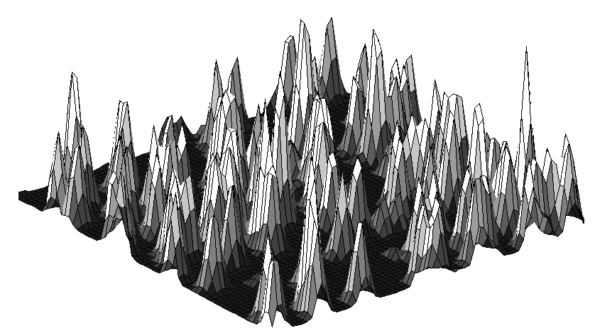  X  (A) | 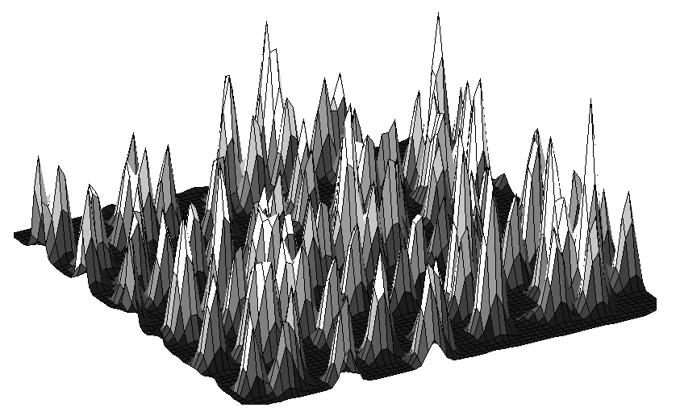  (B)
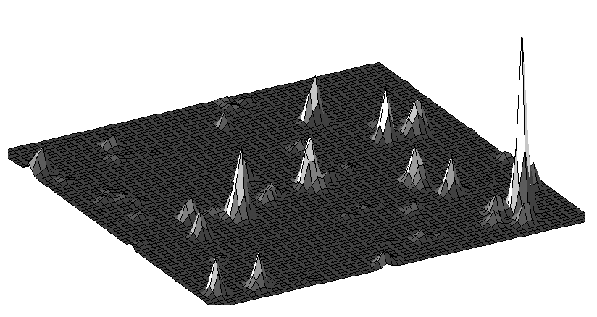

=
(C)
Figure 8. Improved SNR by multiplying corresponding values of each correlation function. Correlation values that do not appear in the same location in each function are eliminated allowing tracer particle displacement to be resolved. (Note paragraph caption format. This format points out the main features the author wants the reader to notice.)

Experimental Validation
(This section presents the method by which you validated your theoretical analysis. It should include a direct comparison of your theory with your experimental results. Note – sensor calibration and error analysis are not generally included in journal paper format.)

(Please keep in mind that the experiment and the comparison of your theory with the experimental results are NOT the objective of your report. The experiments are only a caricature of the actual problem you are investigating and often do not include all of the physics that you must consider. The experiments are simply a way of determining if your theory is correct within the limits of what you are able to measure.)
Discussion
(This section is NOT a discussion of why or why not your theory matched your experimental results. Such analysis belongs in the previous section. This section presents a discussion of your theoretical model and its significance to the problem being solved. The purpose of this section is to provide the reader with insight into the problem. Be sure to present the limitations of your theory including the conditions under which it can and cannot be applied. )

Summary and Conclusions
(Again, this section is not a discussion of how well your experimental results matched your theory. This section simply summarizes the paper, states your findings, and includes any recommendations.)

Acknowledgments
(You do not have to include this section if it is not relevant. The purpose of this section is to give credit to individuals that do not warrant being listed as authors but, nonetheless, contributed significantly to the paper. Often, in technical journals, the source of funding for the work will be acknowledged here. Your 2.672 instructor should, in general, not be listed as it is assumed they provided help. )
References
(Example)
Delnoij, E., J.A.M. Kuipers, W.P.M. van Swaaij & J. Westerweel, “Measurement of gas-liquid two-phase flow in bubble columns using ensemble correlation PIV,” Chem. Eng. Sci., Vol. 55, pp. 3385-3395, 2000.
Hart, D. P., "PIV Error Correction," Experiments in Fluids, 1999.
Hart, D. P., "Super-Resolution PIV by Recursive Local-Correlation," Journal of Visualization, The Visualization Society of Japan, Vol. 10, 1999.
Keane RD, Adrian RJ, “Optimization of particle image velocimeter: I Double pulsed systems,” Meas. Sci. Technol., Vol. 1, pp. 1202-121, 1990.

Annex 1
Put Annex title here

(Do not include computer code or data unless it adds significantly to the readers understanding of the problem or your solution. Even then, it is often better to include a detailed software flow diagram than actual code. Do not include sensor calibration or error analysis as an annex unless it is particularly unusual. You can add detailed mathematical derivations as an annex if they are important to your analysis but you believe its complexity would detract from the general understanding of the paper if placed in the body of the text.)

